**Parkway West Middle PTO**

**November 15, 2022, Meeting**

**7pm Library**

**Call to order:** 7:10 p.m.

**Attendance**: Dana Lorenz, Jeanna Gossett, Stephanie Stokes, Myriam Gitt, Lori Conran, Aurella Clinksdale, Kate Deckelbaum, Casey Pfarr, Tamara Welliner, Lisa Tarter, Pamela Betz, and Anne Branch.

**President’s Update: Julie Wyatt**

* Approve October meeting minutes: First motion: Lisa Tarter. Second motion: Stephanie Stokes.
* Prop S Result: Approved. 76% approval rate. Highest approval rate in history.
* Bell Schedule: Vote is to continue 1-8hr day, 4-4 block schedules. However, 1-8hr day would not always land on a Monday. This change would take effect 23-24’ school year. This vote will be brought to the Parkway School District meeting.
* Chesterfield TIF and Parkway Schools. Parkway is hosting a zoom meeting to learn more on 11-16. This will impact Central area. 3350 condos/townhouses are being built to replace the Chesterfield Mall. Vote is November 21, 2022.
* Special Projects Update; Gaga ball pit installation. Thank you, Conran family for installing the Gaga Ball pit.

**Grant Review; Mike Perlmutter**. Not present. Julie Wyatt presented the teachers grants that needed approval. There is $5000 allocated each school year for teacher grants. $3800 in grants were requested. All were approved. One grant was requested for Beautification. There is $1K in the budget for Beautification. It was determined to use this line item in the budget vs. teacher grant monies.

1st motion: Casey Pfarr.

2nd motion: Lori Conran.

**Bylaws Revision:** **Lisa Tarter**

Lisa Tarter hosted a meeting for anyone in the Parkway West Middle community to attend on October 26th. This meeting was to set to discuss questions or concerns regarding bylaw revisions. Michael Bertz was present for the meeting. It was recommended to add at the date of the bottom of the bylaws and strikethrough for changed recommendations. New by-laws are updated on the PTO website.

The following articles were revised:

Article 5. Section 1.

Section 3. Elections.

Article 6. Section F.

Article

Officers Responsibilities changed.

Article 9. Section B.

1st motion: Lisa Tarter.

2nd motion: Emily Schlick.

Approved.

**VP of Fundraising Committee (Needs a Shadow):  Pamela Betz and Jeanna Gossett**

Direct Giving. We are at $3K of a goal of $12K. It was recommended to create add graphic to the front entry of the school for families to view. Dr. Kealan mentioned the highest need for the school was to upgrade the sound system in the cafeteria and gym. Followed by landscaping the area behind the cafeteria and a new marquee. He will share more information at the December meeting. Once determined the project this will be shared with the families.

Spirit Wear- Steel tumblers, polo’s, pj’s have been added to the store. If you are purchasing a holiday gift you can contact Carrie to not send home. 2-week turnaround time. 3-4 for embroidered items.

Papa Johns: 11-15-21 – Donation night. February 24, 2023, next step.

Pretzel Sales. Not present.

Amazon Smiles/ Box Tops. Don’t forget Amazon Smiles this holiday season.

Rock and Roll Bingo Night. April 1st is the date!

**Treasurer Report (Needs a Shadow):  Emily Schlick**

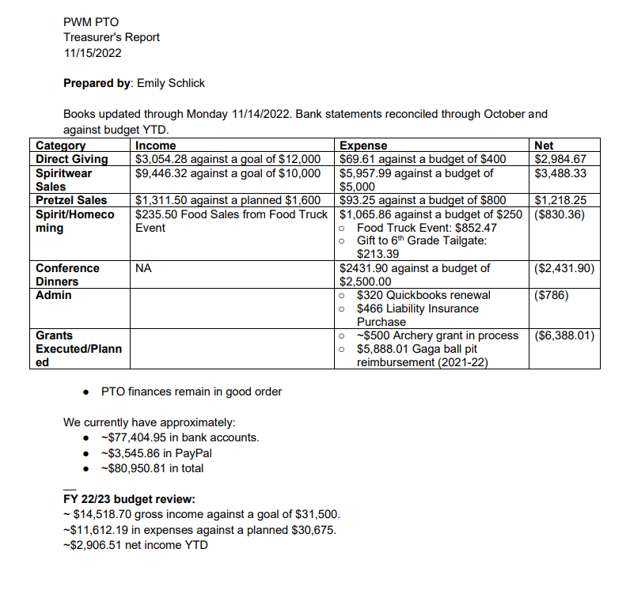

**VP of Communications Committee:  Jen McCurdy.** Not present.

**VP of Community:  Anne Branch**

Staff Appreciation;  Kate Deckelbaum, Lori Conran, Angie Stevens.

1. Adopt-A-Staff. First round of gifts was delivered on 11-14-22. There are two more rounds scheduled for December.
2. Discussed next year to better align with teacher grants not landing on top of adopt-a-staff.

Government Relations; Jennifer McGillivary. Not present.

Cotillion- Jamie Gumpel. This event takes place in Spring. There is discussion about offering this for 8th graders.

Winter Family Event. January 27, 2023. Mario-Kart tournament.

8th Grade Celebration- Mandy Kelly, Kristen Merriman, Robyn Hayes. No update.

Longhorn Pride/Beautification. No update.

Fun Run- Robyn Hayes. March 23’. TBD.

6th Grade Reps; Myriam Gitt Andrews, Stephanie Stokes. December 2. $1000 per grade for entire school year. The reps have planned great parties, but they need more money allocated for the parties. The Board has an ability approve a $500 expenditure. The reps need an additional $699 for the party. 2017 we spent no more than $500 between 3 parties. In 22’ we are projected to spend $4300. Dr. Kealan shared the focus is to create community after the pandemic. He approves shifting money towards parties to help build community for the school if the event is inclusive to all kids. 1st motion: Stephanie Stokes. 2nd motion: Casey Pfarr. to approve $699. The Approved.

7th Grade Reps; Aurealla Clinkscale, Angie Stevens. 7th/8th grade. November 18. Party Like a Longhorn. Gaming Truck and Photo Booth. 300 kids have RSVP to date. The goal is 400. The reps did not realize they could ask for additional funds from the board up to $500. There was discussion if the party needed add’l funding. After realizing there was only one party to plan for the school year for the classes, they have enough money for the event and did not need extra funds.

8th Grade Reps;  Lori Conran, Kate Deckelbaum

**Principal Report- Dr. Kealen**

Veteran’s Day assembly was a success. Staff Appreciation has been a hit. Thank you to Conran family for assembling the gaga ball. The Learning as a staff on Election Day – culturally responsive – youth culture. Age culture. Social age culture. Match classroom strategies with meeting kids where they are. He is going to meet with students who are interested in Public Relations. Teacher or Classroom features where the kids can gather intel and be apart of this process. 7th grade time lead time – Book drive going on. Food drive coming up. And a group is leading Beatification. Upcoming events: Concert season is right around the corner, November, and December. The first school play is December 9th and 10th; Law and Order Fairy Tale unit.

Old Business: None

New Business: None

Next Meeting:  December 13, 2022, 7pm Library

Meeting adjourned at 9:08 pm.